Lesson Plan
Well-being Year 1 age level 13years approx.
Anne Dunne Temple Street Hospital School
2021

Learning outcome: Appreciate the importance of building my own self-esteem and that of others

Be Myself

Aim: The student will design a poster about themselves, experience a time to reflect in a positive way about themselves and create a visual positive self-image.

Teacher Input

Explain what it means to have a self image.
Show a short video (the reflection in me/youtube kids) about self-image or do a short meditation reflecting on the questions below. Allow the students to relax and be comfortable and listen to positive thoughts within them.

After becoming quiet and practicing breathing together bring the student to their favourite safe and comfortable place in their minds. It may be by the sea in the sunshine or in their bedroom listening to music or in a forest sitting on a bench listening to the birds.

Then ask the student to listen and visualise their reflection in the mirror when the following questions are asked in order to reflect on their self-image.

Reflection

“Who else would I be if I wasn’t myself? Of Course I am who I am. But who am I ?

Whether I like peanut butter or marmalade on my toast who I am and being myself means being happy to be myself and not to care about what other people think of me.

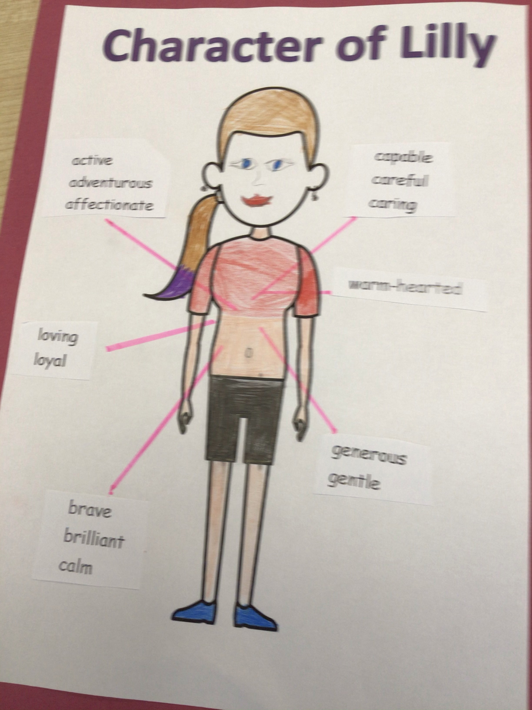
To be myself I have to know who I am.Learn about myself. What I think is important in my life and what I value or believe in.

Listen carefully to your reflection when we ask these questions
Do I know who I am?

When am I most happy?
Where do I feel most comfortable?
What are my favourite things to do?
What excites me and makes me feel passionate about life?
What do I like about myself?
What am I good at doing?
What makes me laugh?

Activity:

Design a poster of my self-image from listening to my reflection in the mirror.
Enjoy making it and put it up in your bedroom to remind you of how perfect you are.

Resources: Video, Quiet music, art equipment, YouTube for kids (The reflection in me)

Evaluation and reflection:
What did I learn from this lesson?
Write and/or share one positive sentence about myself. Use your own name in the sentence.

