Date:20 September 2021 | Age group:13-14
Lesson objective: Exercising gratitude
Development of emotional intelligence, thinking, creativity, personality. Strengthening positive thoughts, emotions and mastering the practice of gratitude.

Resources needed: laptop, speaker, projector, printed quotes, cardboard, ruler, writing tools,
felt-tip pens, coloured pencils, A / 4 sheet, scissors, tape, Happiness book, pebbles
Description of lesson:
1. Organizational tasks
2. -László Váray: Thanksgiving:
https://www.youtube.com/watch?v=PKYIrWWk23I

-Meanwhile handing out gratitude quotes - dragging
-Discussion about the song, its topic.
-Reading quotes, their meaning, their impact on students
discussing.
3. -Preparation of Thanksgiving bell
-Drawing and scheduling lessons. (Later, a joint montage will be made of them.)
4. Expressing gratitude on each other's backs
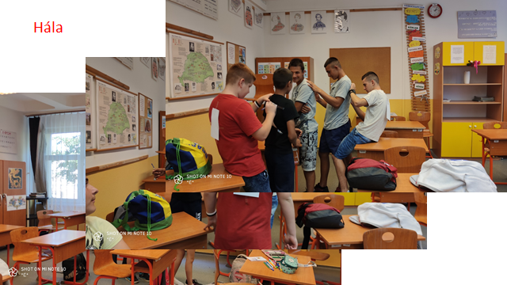
5. -A glass of milk
- The story in the video:
https://www.youtube.com/watch?v=5QPGQB3GMGU
- Discussion and processing of the animated film seen.
- Who means gratitude?
6. Thanksgiving
7. Assigning gratitude stones to each other (Whoever wants to, tells why he gives, who you don't want to, we don't force it.)
8. “Homework” preparation: writing thank you coupons for parents.
9. -Closure: Gratitude to me means… Meanwhile, Kowalsky says Thanks to you c.
number
https://www.youtube.com/watch?v=jadtGMYYZBg

Outcome: Grateful thinking can neutralize negative feelings: envy, greed, hostility, anxiety, annoyance, resentment, and even loneliness as well.


Next steps/follow-on activity:
Practising optimism

II Rákóczi Ferenc Általános Iskola Berettyóújfalu,Hungary
by Teberánné Körtvélyesi Éva

