Date:  6 September 2021 | Age group:  13-14
Lesson objective: Setting and achieving goals
Strengthening, motivating, activating,developing endurance
Resources needed: laptop, projector, speaker, printed quotes, Happiness book, colourful
cardboard, felt-tip pens, picture of classroom decoration, pictures of athletes - puzzle, chairs
Description of lesson:
1. Organizational tasks
2. - Béla Pintér: This is your day
https://www.youtube.com/watch?v=MNlX56Ua8EY

- Singing, moving
- Choosing quotes about achieving goals and justification
3. Palm drawing for purposes
(Everyone draws their hands, writes on their fingers their goals for the second semester,
what you want to achieve. We will evaluate it at the end of the year.)
4. - The young man and the angel c. tale - The processing of the story
- Conversation: What if…?
5. Chair holder
(Purpose: to prevent the player from sitting on the empty chair.)
6. Image analysis
- Which step are you on? (Picture on the classroom wall) Who keeps your goals where
in achieving?
7. How can you achieve your goals? How do you plan? Talk about "stairs"
Take small steps to your destination: https://www.youtube.com/watch?v=wivgAVhJRLU
8. Message from the future
(Write to yourself a message from ten years later! What did you achieve of your current goals?)
Outcome: It is not enough to set goals, you have to find the way to them. From the many small steps the "big whole" will come together.
Setting and achieving goals helps you schedule time, supports self-esteem,
educates on a regular basis, helps to cope with difficulties, promotes social relationships
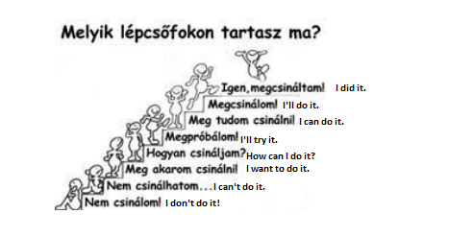
Next steps/follow-on activity: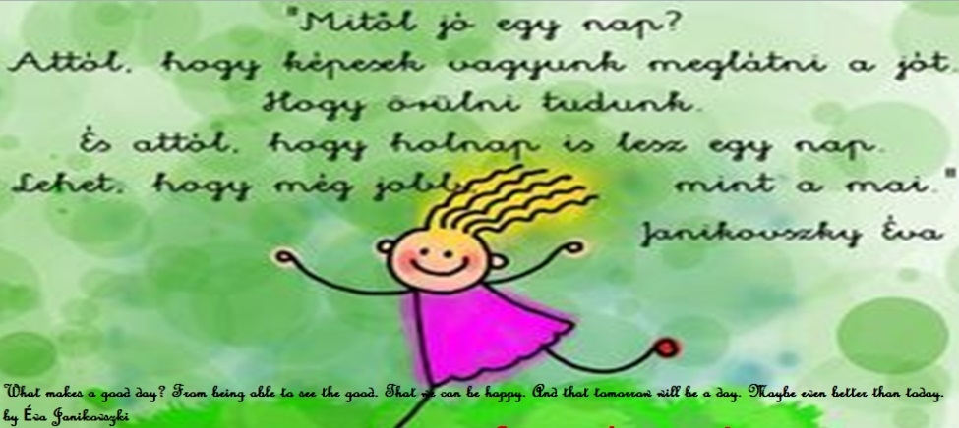

Coping strategies

II.Rákóczi Ferenc Általános Iskola,Berettyóújfalu,Hungary
by Teberánné Körtvélyesi Éva

